**Data Flow Diagram:**

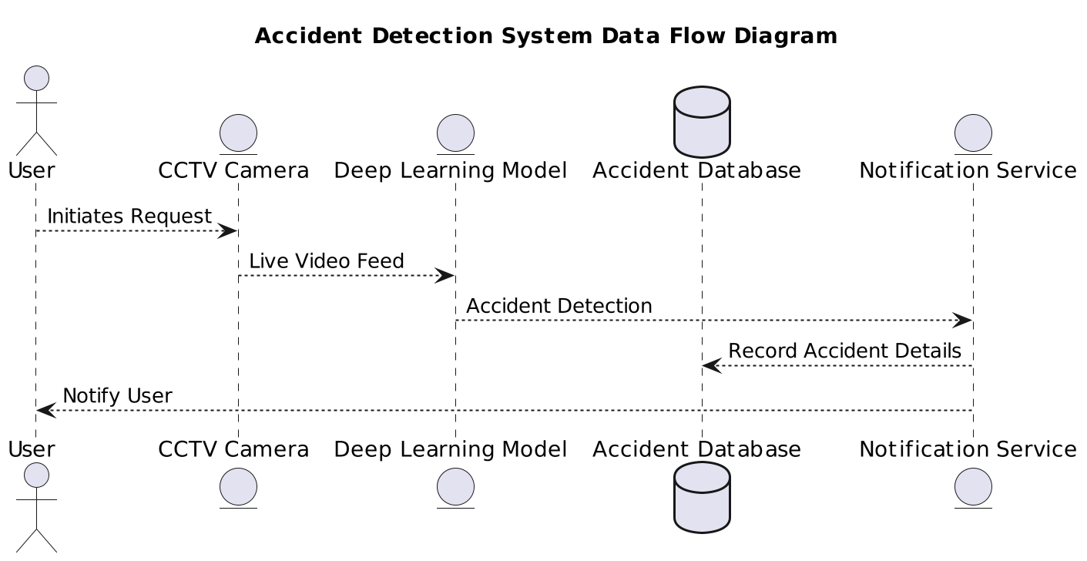

1. **Title:** The title of the diagram is "Accident Detection System Data Flow Diagram". This provides an overview of the purpose of the diagram.
2. **Actors and Entities:**
   * **User:** Represents the individual who initiates the request for accident detection.
   * **CCTV Camera (Camera):** Represents the device that captures the live video feed of the highway.
   * **Deep Learning Model (DLModel):** Represents the model trained to detect accidents from the video feed.
   * **Accident Database (AccidentDB):** Represents the database where information about detected accidents is stored.
   * **Notification Service (NotificationService):** Represents the service responsible for notifying users about detected accidents.
3. **Data Flow:**
   * **User -> Camera:** The user initiates a request for accident detection, which is sent to the CCTV camera.
   * **Camera -> DLModel:** The CCTV camera provides the live video feed to the deep learning model for analysis.
   * **DLModel -> NotificationService:** Upon detecting an accident, the deep learning model sends the information to the notification service.
   * **NotificationService -> AccidentDB:** The notification service records the details of the detected accident in the accident database.
   * **NotificationService -> User:** Finally, the notification service notifies the user about the detected accident.
4. **Coloring of Arrows:**
   * The **skinparam arrow** directive is used to set the color of the arrows in the diagram. Both the border color and the fill color of the arrows are set to DarkGreen.

This diagram visually represents the flow of data and interactions between different components of the accident detection system, from the user's request to the notification of the detected accident.